|  |  |  |
| --- | --- | --- |
| Product Catalogue | Gold Finger Connector |  |
| Connector Types | mPCI-E |  |
| Spacing | 0.8mm |  |
| Total number of pins | 52 |  |
| Installation method | Supporting pad |  |
| Board height | 5.2mm |  |
| Operating temperature range | -40℃~+80℃ |  |

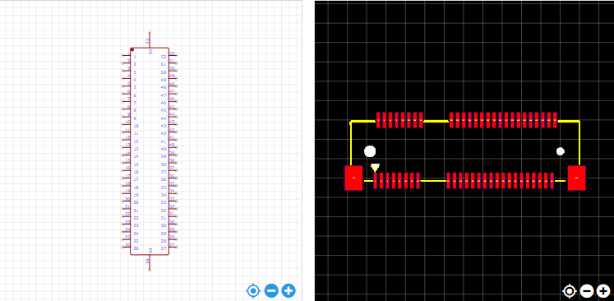

<https://item.szlcsc.com/197342.html>